Results

Kendra Wyant

2021-03-02

# Participant Characteristics

## Willingness to Participate

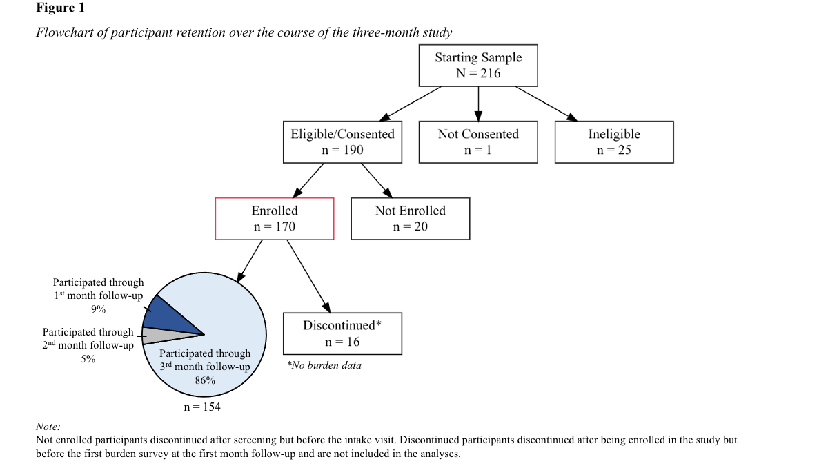

# Burden

## Interference

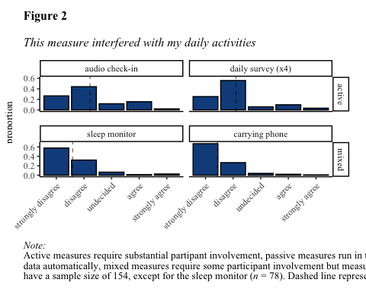

## Dislike

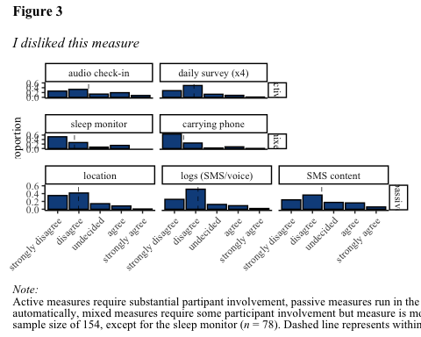

## Willingness to Continue

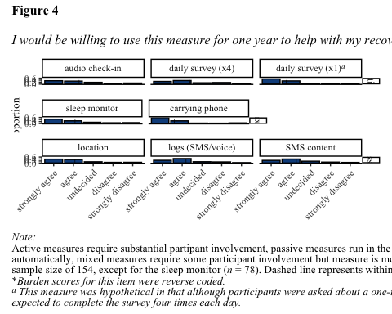

## Analysis

# Compliance